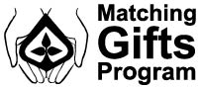
Another way that NGL extends its outreach to Dane County and surrounding communities is by offering the Matching Gifts Program, which works to encourage and support the generosity and community involvement of our employees. Each employee has the opportunity to donate money to the non-profit agency of their choice and have their donation matched by NGL, which doubles the amount of the original gift! These matched gifts help make a positive impact in our community and in the world. Since its creation in 2010, over 300 employees have participated with donations to many different organizations such as Big Brothers Big Sisters, The Smile Train and National Childhood Cancer Foundation.
For more information on the Matching Gifts Program, please contact Elizabeth Barden at ejbarden@nglic.com or 608-443-5373.

